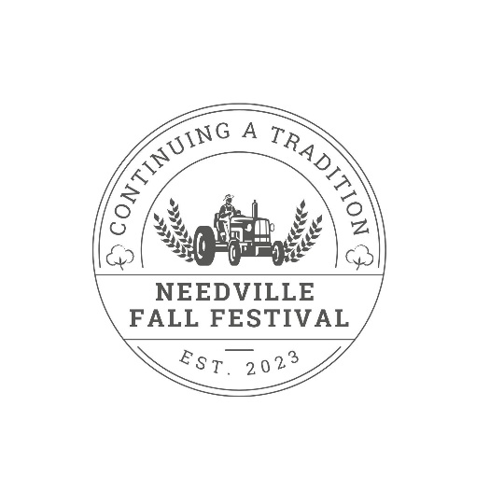

1st Annual Needville Fall Festival BBQ Cook-off
Needville Youth Fair Grounds – Needville, TX
Oct. 18th-19th, 2024

OFFICIAL RULES

The Needville Fall Festival is pleased to announce the 1st Annual BBQ Cook-Off to benefit the youth of Needville while keeping small town traditions alive. Small town traditions in Needville have always been a value of the people on this committee and want to see them stay alive. One of the biggest traditions was a big BBQ cook-off in the fall where you could have a friendly competition, spend time with friends and family and just enjoy life.

In order to keep this event going for years to come, we ask that you read the rules set forth in this document with care and consideration. It is the responsibility of the Head Cook to ensure that all members are aware and abide by these rules. Failure to comply with all rules and regulations will result in disqualification and the team(s) will not be invited to return to any subsequent cook-offs.

GENERAL RULES

1. Only the first 40 COMPLETE entries will be accepted.
2. Entry forms/fees must be RECEIVED by 5:00 p.m. on Friday, Oct. 18th, 2024.
3. Teams may start moving in on Friday, Oct. 18th at 8:00 a.m.
4. UTV’s & Golf carts will not be allowed in the cook-off grounds
5. Head cooks who are entered into jackpot fajitas and creative cocktail categories will be required to attend the head cook’s meeting in the arena at 6:00 p.m., Friday evening. For all other categories, head cooks will meet at 9:00 a.m. Saturday in the arena. There will be short announcements, comments, and the distribution of the containers during this time. Please be prompt. If running late, please contact Burley Gunter- (979) 429-1246
6. Alcohol will not be provided but may be brought onto the youth fairgrounds. Any illegal activity or physical altercations will be handled by on-duty Law Enforcement Officers. If you plan to drink, do not drive. Be responsible. We want this to be a safe and enjoyable event for all.
7. Teams will be responsible for the COMPLETE clean-up of their space before departure on Sunday. All trash must be disposed of properly. We will be driving around collecting trash. Large trash bags will be provided if needed. COALS SHOULD NOT BE DUMPED ON THE GROUND.
8. Contestants will not be allowed to sell any BBQ, they may give away samples if they wish.
9. Sites do not have power or water so plan accordingly.
10. ABSOLUTELY no firearms or explosives will be allowed.
11. Amplification should be used in moderation and must be turned off by midnight (12:00 a.m.) on Friday & Saturday night.
12. BBQ Chairman reserves the right to make additional regulations as situations warrant.
Decisions of the committee and judges will be final. BBQ Chairman has final say on all decisions.

COOK-OFF RULES

1. All entries must be cooked/prepared on-site.
2. No pre-seasoned meat may be used, with the exception of beef fajitas.
3. Seasoning and/or cooking of meat may begin once the team has been checked in and meat has been inspected.
4. No gas, electric, or propane assist cookers (including pellet cookers) allowed. Sauce or garnishments may not be added to entries at judging time. Sauces may be used as a “sop” during cooking and must be cooked on, but not poured on for presentation.
5. Foil will be allowed in containers and given to you at container pickup. No other things are allowed in the containers but foil.
6. Ribs are to be PORK RIBS. St. Louis Style ribs will be accepted. Absolutely NO Baby Back Ribs accepted.
7. Chicken must be either a whole chicken or fully jointed, wingtip or no wingtip, whole half chicken. A whole, fully jointed half chicken will be required for turn in.
8. Overall Champion will be decided by the combination of scores from the ribs, chicken, and brisket categories.
9. If there is a tie for Overall Champion, the highest placing in the brisket category will be used as the tie breaker. If the tie is not resolved, then the chicken category will be used, then ribs.
10. Creative cocktail judging will be done in the arena where the other categories will be judged. You will provide your own cup, garnishes, etc. and must check in cup in arena at head cooks meeting Friday evening to get a ticket attached to cup.
11. Teams must be entered in the Saturday portion of the cook off to be eligible to enter the jackpot categories.

Turn In Schedule

Friday, Oct. 18th
8:00 PM – Jackpot Fajitas (7 slices)
9:00 PM – Creative Cocktail (1 cup)

Saturday, Oct. 19th
12:00 PM – Chicken (Whole Half at turn in)
1:30 PM – Ribs (7 ribs)
3:00 PM – Brisket (7 slices)

If there are any questions, please contact Burley Gunter at (979) 429-1246.

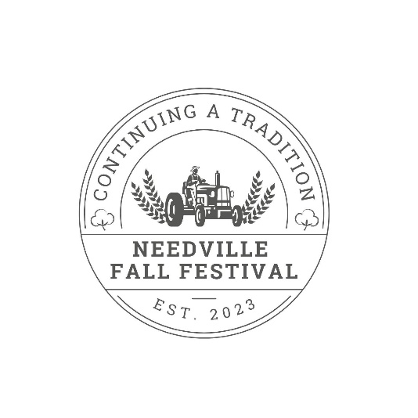

1st Annual Needville Fall Festival BBQ Cook-off
October 18th-19th
Needville Youth Fairgrounds– Needville, TX

OFFICIAL ENTRY FORM

TEAM INFORMATION:

Team Name: _____________________________________________________
Head Cook: ______________________________________________________
Phone #: ______________________________
E-mail: ____________________________________________________________
Address: _____________________________________________________________________________________________

_____________________________________________________________________________________________
Additional Team Members: 1. __________________________________________________________________
2. __________________________________________________________________
3. __________________________________________________________________
4. __________________________________________________________________
ENTRY INFORMATION (please mark categories you will participate in):
_____ Brisket/Ribs/Chicken _____ Jackpot Beef Fajitas ____ Jackpot Creative cocktail
($200 entry for all) ($20 entry) Friday Night ($20 entry) Friday Night

● 1st through 5th in Brisket/Ribs/Chicken will receive trophies
● Jackpot entry winners will receive 50% of the entry fees collected for each category

RELEASE FORM (Head cook MUST sign):
The Needville Fall Festival Foundation, its Designees, Agents, or Representatives shall in no case be responsible for any loss, damage, or injury to any persons or property regardless of how such loss, damage, or injury is occasioned and by whom said Organizations or Persons shall be indemnified and saved harmless from any and all claims, suits, or judgments brought by anyone as a result of such loss, damage, injury, or claim.
Entrants agree to abide by the rules and regulations of the Needville Fall Festival BBQ Cook-Off, its delegated representatives, and the Needville Youth Fair Grounds.

Head Cook Printed Name _________________________________
Head Cook Signature ____________________________________

Please read the above form, sign, and mail along with payment to: Needville Fall Festival
P.O. Box 1057 1 Needville, TX 77461
A check, payable to Needville Fall Festival for the full amount must accompany your entry.

SPACE IS LIMITED TO THE FIRST 40 PAID ENTRY FORMS RECEIVED ** DEADLINE FOR ENTRY IS 5:00 P.M., FRIDAY, October 18th, 2024**

